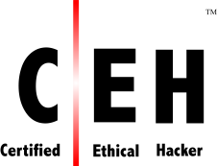
Course Outline – CEHv11
Module 01: Introduction to Ethical Hacking
Module 02: Footprinting and Reconnaissance
Module 03: Scanning Networks
Module 04: Enumeration
Module 05: Vulnerability Analysis
Module 06: System Hacking
Module 07: Malware Threats
Module 08: Sniffing
Module 09: Social Engineering
Module 10: Denial-of-Service
Module 11: Session Hijacking
Module 12: Evading IDS, Firewalls, and Honeypots
Module 13: Hacking Web Servers
Module 14: Hacking Web Applications
Module 15: SQL Injection
Module 16: Hacking Wireless Networks
Module 17: Hacking Mobile Platforms
Module 18: IoT Hacking
Module 19: Cloud Computing
Module 20: Cryptography

